Outline (After midterm):

* RNN/LSTM/GRU/Attention/Autoencoder
* GAN
* Learning Theory
* Reinforcement learning
* Graphical model
* SVM
* Ensemble learning
* Feature selection
* PCA
* Active learning/ Semi-supervised learning
* Adversarial learning

**Reinforcement learning:**

Bellman’s equation:

Using value iteration to find best strategy:

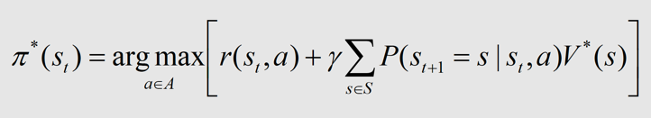

Value iteration for learning V*

(assumes we have a model of the world: i.e. know P(st | st-1, at-1))

Q-learning: (deterministic VS. non-deterministic)

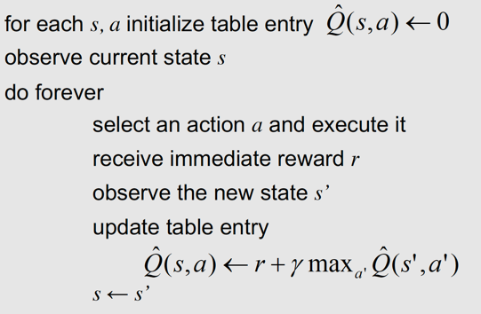

* Exploitation: in order to learn about better alternatives, we shouldn’t always follow the current policy
* Exploration: sometimes, we should select random actions

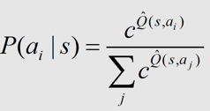

where c > 0 is a constant that determines how strongly selection

favors actions with higher Q values

Using deep learning net to approximate Q-table:

Loss = pred_Q(s,a) – [r+ gamma*max(Q(s’,a’))] 🡺 prediction – calculation

**RNN/LSTM/GRU**

**Encoder-decoder/Attention**

**Autoencoder & PCA**

Undercomplete linear autoencoder 🡺 PCA

* Undercomplete linear autoencoder: Minimizes (x’ - x)^2
* PCA: Maximizes variance

According to 勾股定理, these two objective functions **are equivalent.**

